PRELIMINARY ENQUIRY

PLANNING DOCUMENT

The intention of this form is to provide an overview of all questions included in the Preliminary Enquiry online process. The system does not remember what you have entered to come back to later. You can change your entries before submitting. Please plan your submission using this document, and then submit your enquiry using the online form.

The Preliminary Enquiry is a brief overview of your project and request. If we wish to progress the proposal, you will be invited to complete the more comprehensive Grant Submission form. We trust that this 2 stage process will minimise any unnecessary effort by the enquirer.

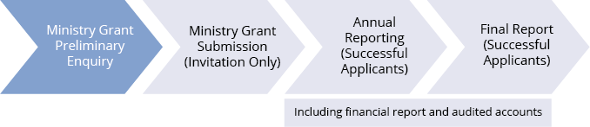

Instructions to complete this form:
- Read the criteria and FAQs on the Genesis website
- Note the next lodgement period on our website
- Complete the online form. There are no attachments for the Preliminary Enquiry form.

- About the Enquirer
Title of your project | Name of Proposed applicant
Contact person name
Position & Phone | Email
Project Start date | Project End date
Proposed Genesis funding period | Annual income of the applicant
Prospective income sources to support | the project (pending and confirmed)

2. About the proposed applicant
Does the potential grantee have tax deductible (DGR Item 1) status? | YES/NO
Is the potential grantee a Tax Concessional Charity (TCC)? | YES/NO
You must answer at least one question above “yes”; otherwise we cannot help you.
When does your financial year end? (30 June/ 31 December/ Other)
Provide a brief description of the proposed applicant, including its mission/vision and experience (max 100 words)

- About the Request
Provide a summary of the project (max 100 words)
How will the project aid the spread of the Gospel? (max 100 words)
Summarise the Project’s anticipated outcomes.
(Please include numeric measurable targets. Detailed KPIs will be requested in the Grant Submission form)
Budget Income
Provide an overview of the project budget, including income sources and expenses and excluding the Genesis request over 3 years (a detailed budget will be required if successful for the Grant Submission stage).

Year ended: | 30/06/__ | 30/06/__ | 30/06/__
Income source A
Income source B
Income source C
Total Income
Budget Expenditure
Expense A
Expense B
Expense C
Total Expenditure
Need/Surplus

What amount are you requesting from Genesis (for each project year)?

Year ended: | 30/06/__ $______ | 30/06/__ $_______ | 30/06/__ $_______

- Other
How will the project continue to be funded after the completion date of the grant? (max 100 words)
How did you learn about Genesis?

